## Contents

***TOPICS PAGE NO.***

|  |  |  |
| --- | --- | --- |
| 1. Abstract |  | 1 |
| 2. Introduction |  | 1 |
| 3. Purpose |  | 1 |
| 4. Modules |  | 2 |
| 5. Advantage |  | 2 |
| 6. Disadvantage |  | 2 |
| 7. Feasibility Study |  | 3 |
| 8. Project Category: Web Based Application |  | 4 |
| 9. Use Case Diagram |  | 5 |
| 10. Sequence Diagram |  | 6 |
| 11. Data Flow Diagram(DFD) |  | 7 |
| 12. Entity Relationship Diagram |  | 8 |
| 13. User Interface Snapshots |  | 9-13 |
| 14. Database Tables |  | 14-18 |
| 15. Sample Codes |  | 19-30 |
| 16. Features of Restaurant Management System |  | 31 |
| 17. Future Scope Of this Work |  | 31 |
| 18. Conclusion |  | 31 |
| 19. Bibliography |  | 32 |

### Abstract:

“Employee Database And Payroll Management System” is designed to make the existing manual system automatic with the help of computerised equipment and full-edged computer software, fulfilling their requirements, so that their valuable data and information can be stored for a longer period with easy access and manipulation of the same. The required software is easily available and easy to work with. This web application can maintain and view computerised records without getting redundant entries. The project describes how to manage user data for good performance and provide better services for the client.

### Introduction

The proposed project “Employee Database and Payroll Management System” has been developed to overcome the problems faced in the practicing of manual system. This software is built to eliminate and in some cases reduce the hardships faced by the existing system. Moreover this system is designed for particular need of the company to carry out its operations in a smooth and effective manner.

This web application is reduced as much as possible to avoid errors while entering data. It also provides error message while entering invalid data. It is user-friendly as no formal knowledge is required to use the system.

Human resource challenges are faced by every organization which has to be overcome by the organization. Every organization has different employee and payroll management needs. Therefore I have design exclusive Employee and payroll Management System that are adapted to the organization’s Managerial Requirements.

**Purpose**

The purpose of this document is to describe the functionality and specifications of the design of a web application for Managing Employees and their payroll. The expected audiences of this document are the developers and the admin of the web application. Now with the help of this system the admin has the information on his finger tips and can easily prepare a good record based on their requirements.

Finally, we can say that this system will not only automate the process but save the valuable time of the manager or the admin, which can be well utilized buy his institute. This will be an additional advantage and management of power based on their free time from his normal duty.

Modules:

Admin

The Admin gets logged in by valid username and password. Admin can add new Employee, add new Department, add new Pay Grade for the employees. Admin can set the ‘from’ and ‘to’ date worked by an employee in a department with specific pay grade. The Admin can generate an automated monthly salary of an employee. The admin can view all the past records of any recorded employee.

### Advantages

* It is cost effective as the user control the web application himself and does not go for professional service.
* It saves time as it speeds up every aspect of the employee database management and payroll process with a range of automated features.
* It is secure as the employee database and the payroll process is managed by the admin in house rather than sending private information to a third party.
* Validating procedures and checks restrict user from making mistakes.
* The software is easy to use and is user friendly so no expertise is required.
* The calculations are automated so no chance of error.

### Disadvantages

* It requires an internet connection.
* It requires large database.

FEASIBILITY STUDY

After identifying the scope of the project, the feasibility study is needed to be carried out. It is basically keeping the following points in mind.

**Building the software for meeting the scope:** This software has met the scope. As there is no data involved in the system, processing on the file, and the behaviour of this project is already identified and bundled in quantitative manner.

The processing of this software is very simple as it has been designed in php and it has been well divided into several functions according to the need.

**Technically feasible:** This software is very much technically feasible. This software is very much concerned with specifying equipment and the software will successfully satisfy almost all the admin’s requirements. The technical need for this system may vary considerably but might include:

1. The facility to produce output in a given time.
2. Response time under certain conditions.
3. Ability to process data at a particular speed.

Therefore, the basic input/output of data is identified. So, the project can easily be build up and it will also be technically feasible.

**State of Art:** The project is very much within the state of art since the project is a WINDOWS based; it uses very modern and common technique.

Beside it is very much modern and user friendly. It also works as middleware i.e. only in between the user and the file. So, it is completely a state of art project.

**Financially Feasible:** The project is very much financially feasible. The implementation and development cost of this software under the reach of any college.

Moreover, it requires some training for the use. So, training cost can be neglected and the resources of this software are very much available. It also reduces the labour and extra cost to be paid for labour. So indeed, it is financially feasible.

**Resources:** As motioned earlier that the resources are easily available and the cost of training is almost negligible. Sometimes situations may arise when it may not be so much easy. For a person completely unaware of using a computer system could result in a training cost or for a very small organization the purchase of a computer, instalment of the system and other charges may lead to a difficult matter.

# Project Category: Web-Based Application

#### Available Technologies:

Languages: HTML, PHP, JavaScript RDBMS: Online MySQL

Web Server: WAMP server

Development Platform: Visual Studio .

#### Tools Used:

Editor Used: Dreamweaver for PHP, WAMP server for MySQL Operating System: Windows 10

#### Hardware Used:

Processor: Intel core i3 RAM: 2GB

Hard Disk: 1TB

**Use Case Diagram:**

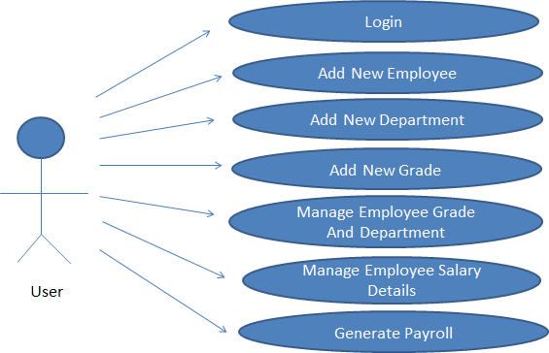

**Sequence Diagram;**

User Application Database

Open application

Enter Login credentials

Successfully logged in

Select required option

Request for required option

Required option selected successfully

Display required page

Insert the required details

Passes entered details

Details entered successfully

Display the details entered

Select record

Request for Report

Display the Report

Report

DFD(Data Flow Diagram)

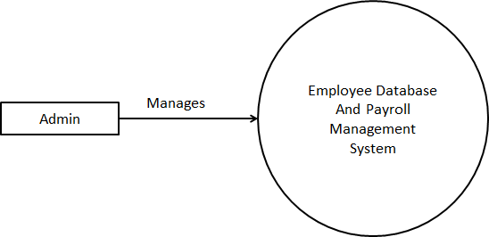

**Level 0**

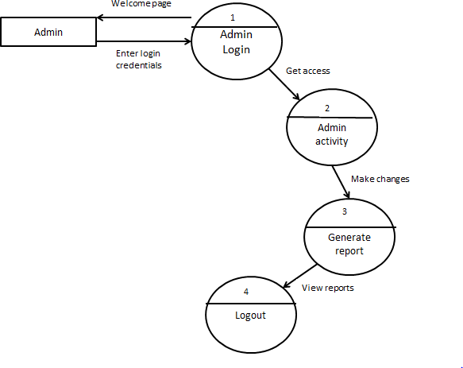

**Level 1**

Entity Relationship Diagram(ERD)

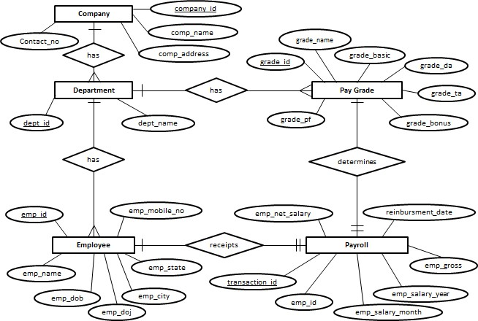

Screenshots

**Login Page:**

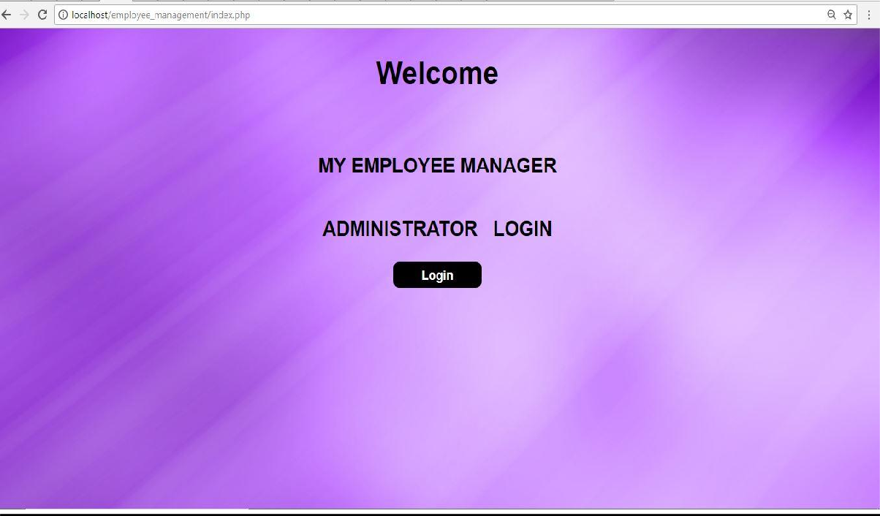

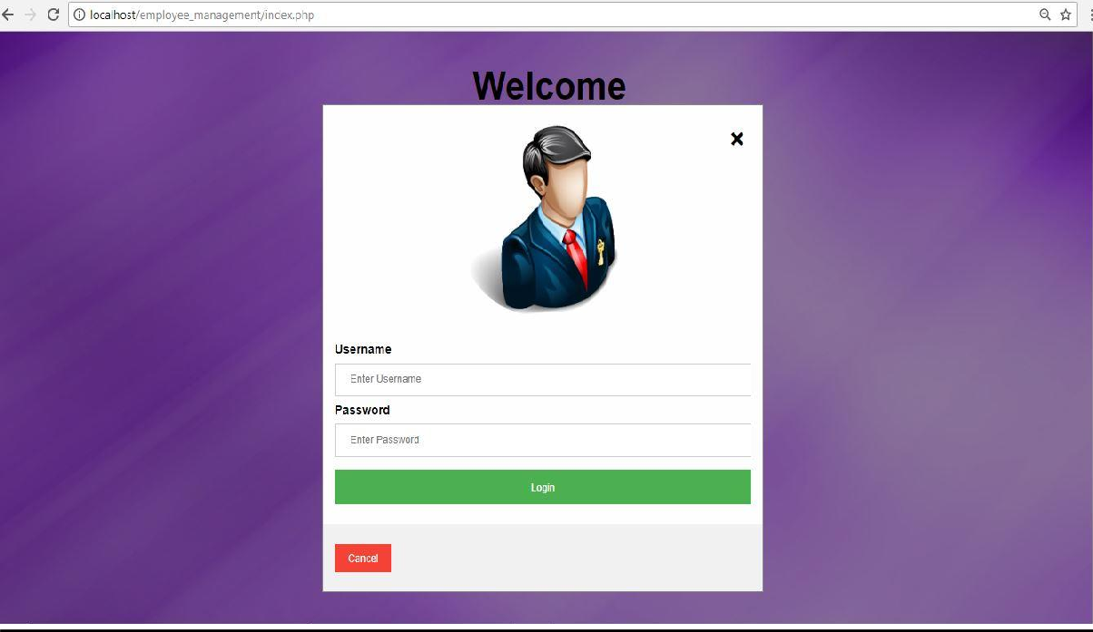

**Welcome Page:**

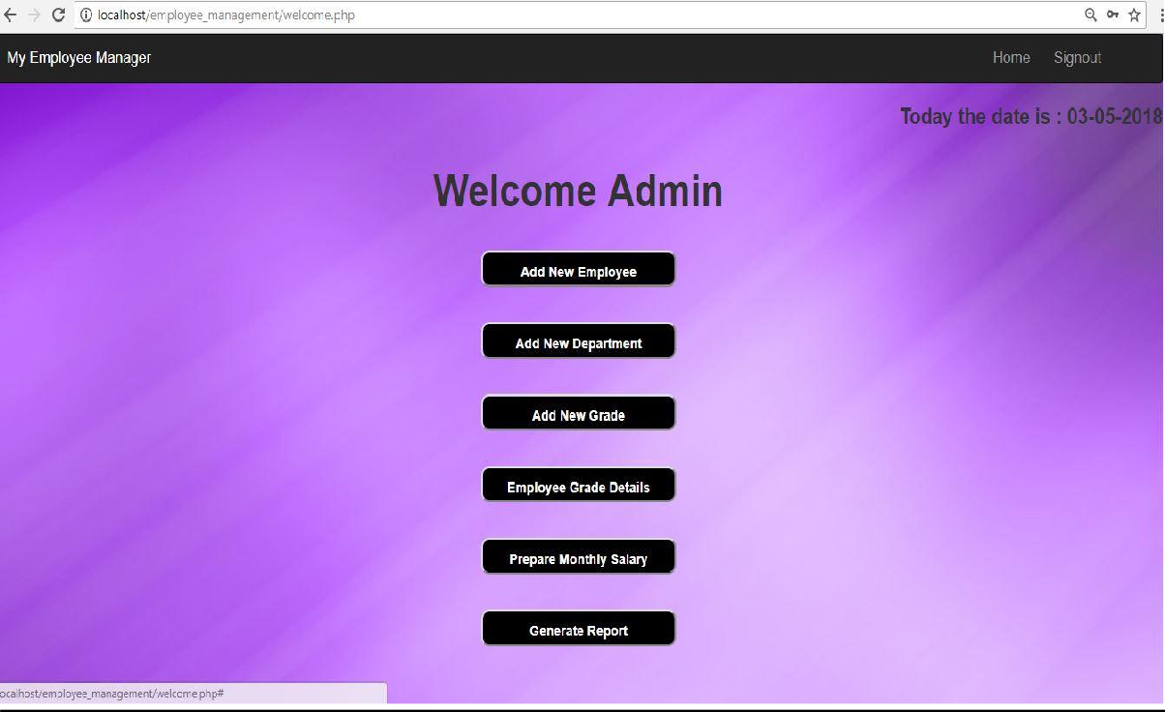

**Employee Details page:**

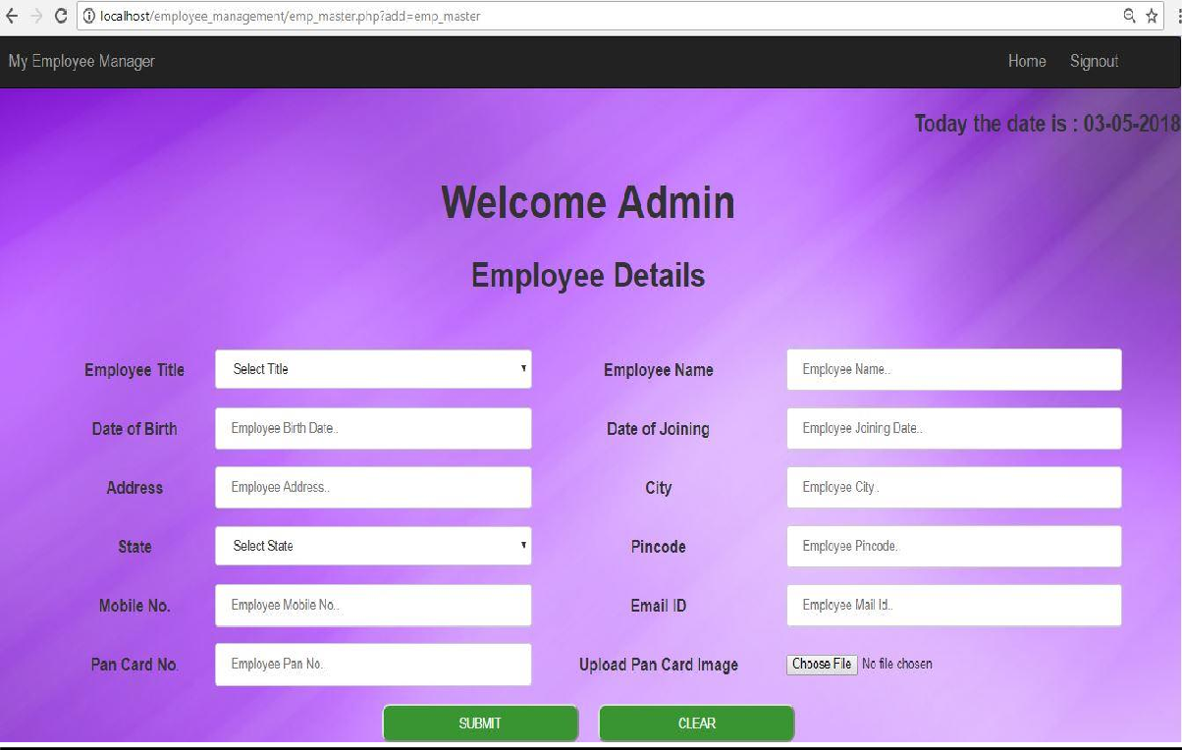

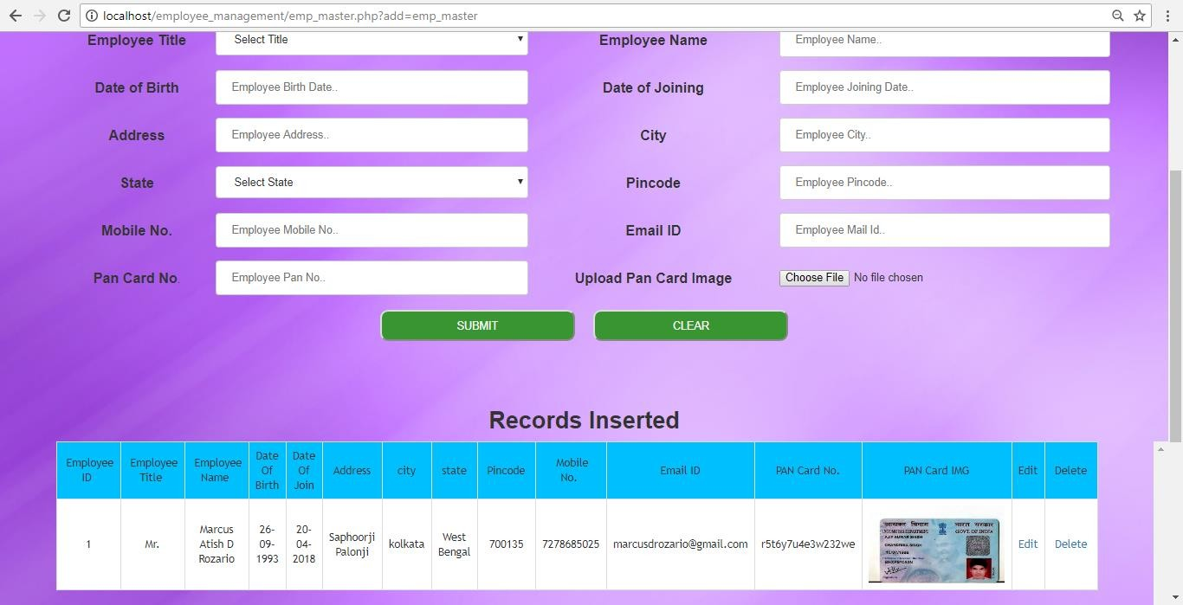

**Department Details Page:**

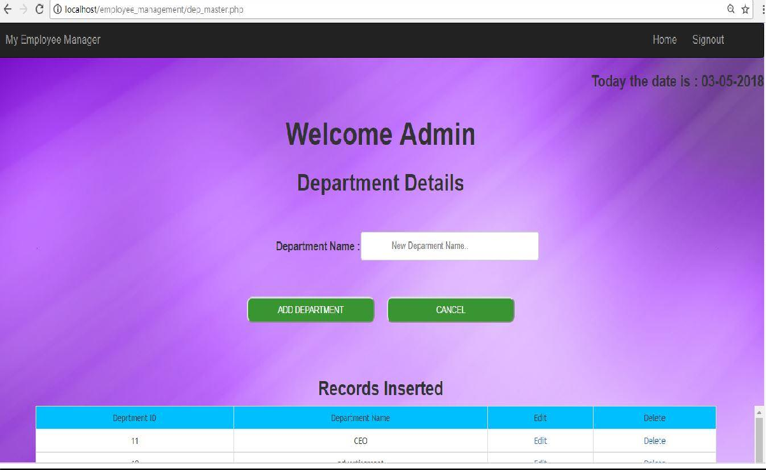

**Grade Details Page:**

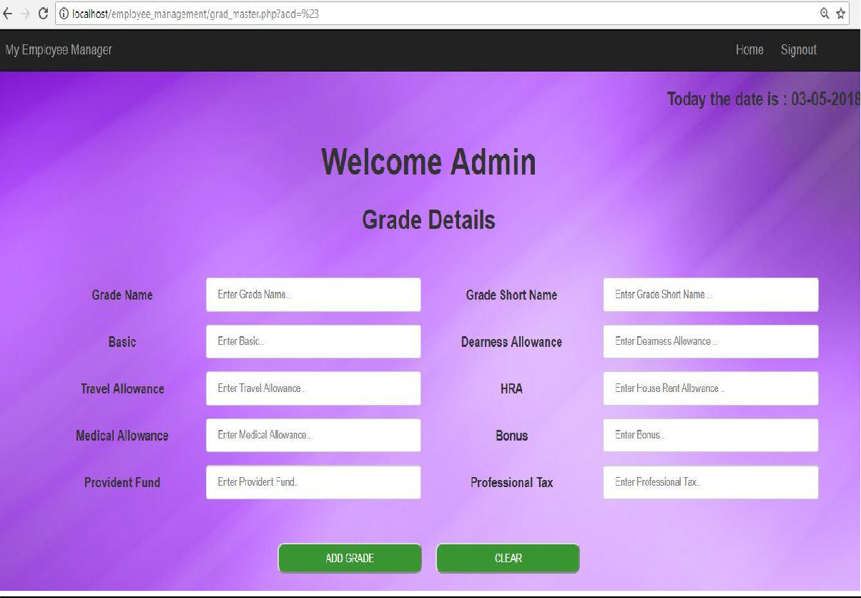

**Employee Salary Details page:**

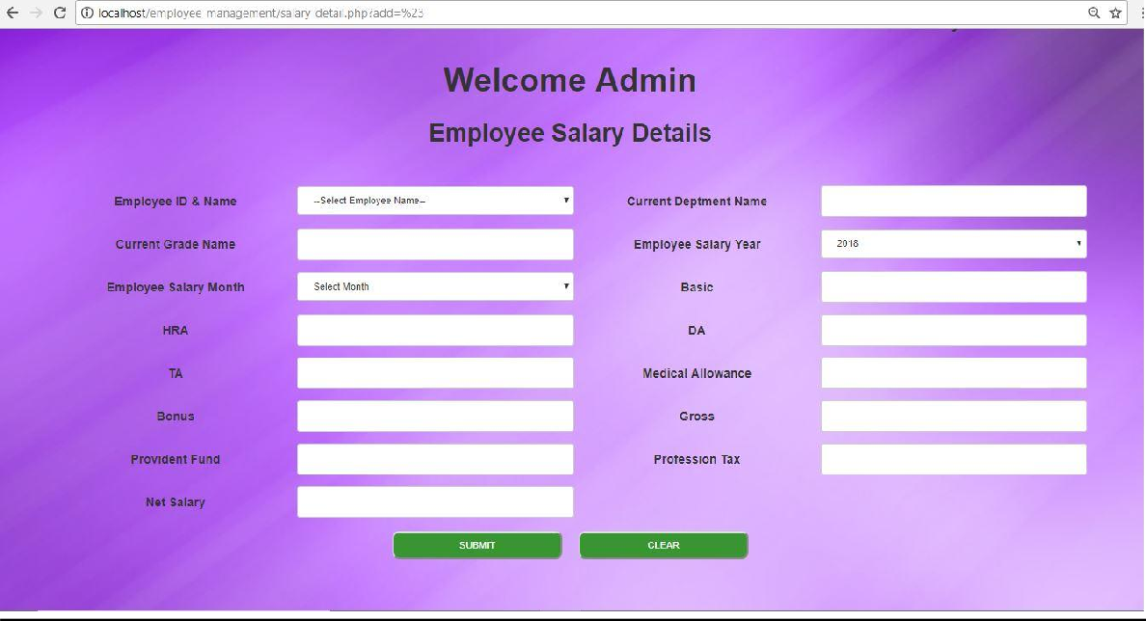

**Employee Report Page:**

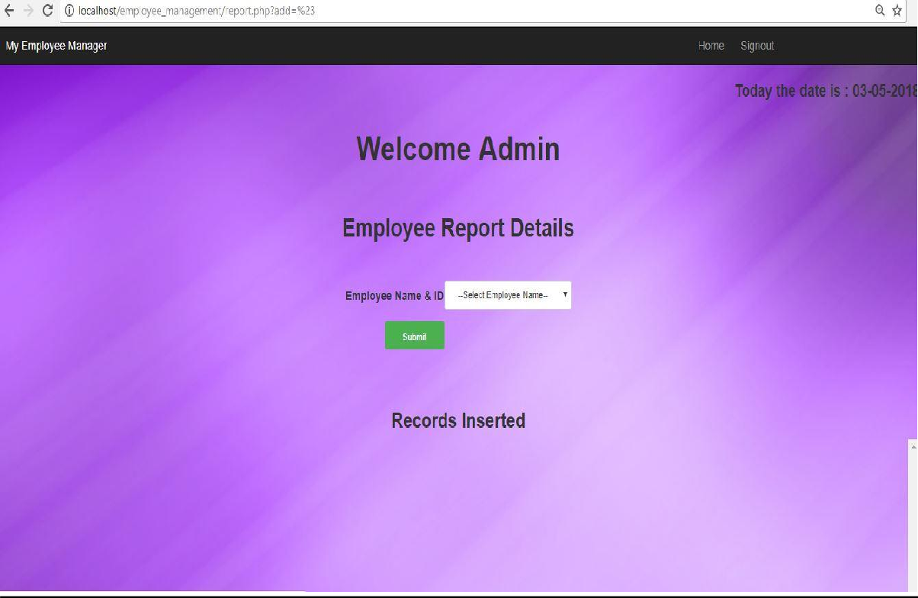

**Database Tables:**

**User Table Database Structure:**

|  |  |
| --- | --- |
| user_id(int) – Primary Key | Id for the user. |
| user_name(varchar) | Enter the name of the user. |
| password(varchar) | Enter the password of the user. |
| email_id(varchar) | Enter the email_id of the user. |
| usertype(varchar) | Enter the type of user. |

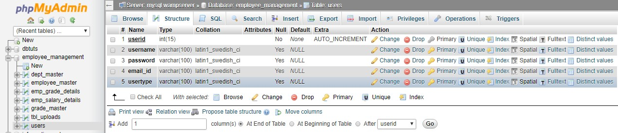

**Department Table Database Structure:**

|  |  |
| --- | --- |
| dept_id(int) – Primary key | Id of the Department. |
| dept_name(varchar) | Name of the Department. |

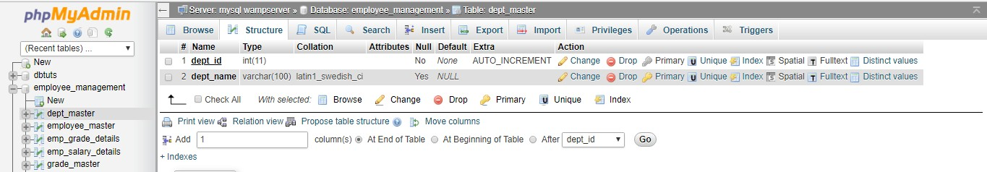

**Grade Table Database Structure:**

|  |  |
| --- | --- |
| grade_id(int) – Primary Key | Id of the pay grade. |
| grade_name(varchar) | Name of the pay grade. |
| grade_short_name(varchar) | Short name of the pay grade. |
| grade_basic(int) | Enter the basic amount. |
| grade_ta(int) | The amount of the Travel Allowance. |
| grade_da(int) | The amount of the Dearness Allowance. |
| grade_hra(int) | The amount of the House Rent Allowance. |
| grade_ma(int) | The amount of Medical Allowance. |
| grade_bonus(int) | The amount of bonus received. |
| grade_pf(int) | Amount of Provident Fund to be deducted. |
| grade_pt(int) | Amount of Professional Tax to be deducted. |

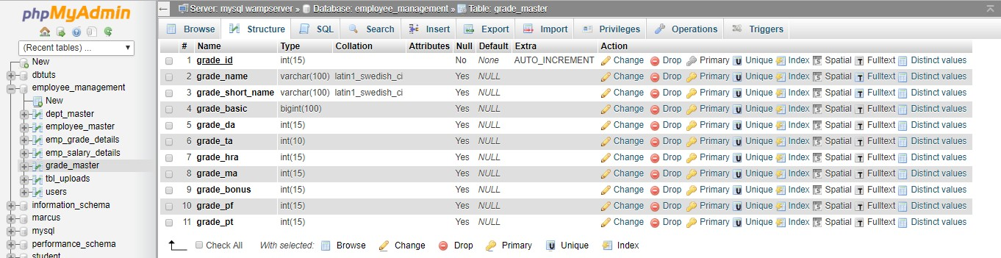

**Employee Table Database Structure:**

|  |  |
| --- | --- |
| emp_id(int) – Primary Key | Id of the employee. |
| emp_title(varchar) | Enter the title of employee. |
| emp_name(varchar) | Enter the name of employee. |
| emp_dob(date) | Enter the date of birth of employee. |
| emp_doj(date) | Enter the date of join of employee. |
| emp_address(varchar) | Enter the address of the employee. |
| emp_city(varchar) | Enter the city of the employee. |
| emp_pincode(int) | Enter the pincode of the employee. |
| emp_mobile_no(int) | Enter the mobile number of the employee. |
| emp_state(varchar) | Enter the state of the employee. |
| emp_mail_id(varchar) | Enter the mail id of the employee. |
| emp_pan_no(varchar) | Enter the Pan number of the employee. |
| emp_upload_pan() | Enter the pan card image of the employee. |

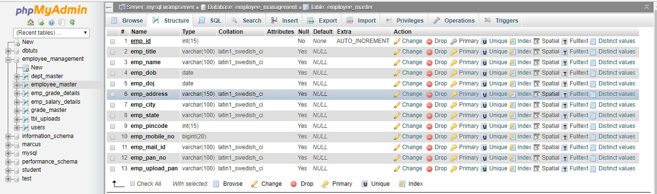

**Employee Grade Details Table Database Structure:**

|  |  |
| --- | --- |
| transaction_id(int)- Primary Key | Unique transaction id. |
| emp_id(int) | Employee id of employee. |
| emp_dept_id(int) | Department Id of employee. |
| emp_grade_id(int) | Grade Id of employee. |
| emp_from_date(date) | Date of join of employee in a department. |
| emp_to_date(varchar) | Last date of an employee in a department. |

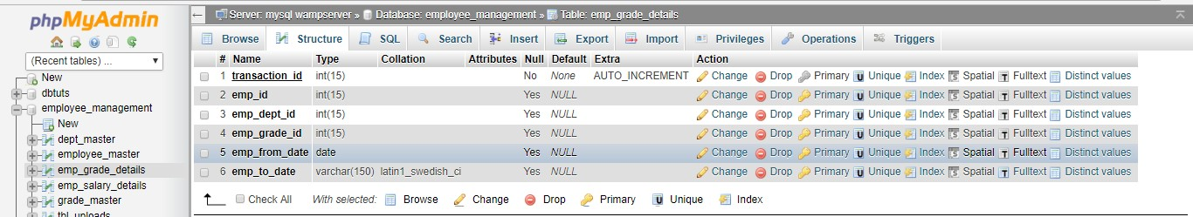

**Employee Salary Details Table Database Structure:**

|  |  |
| --- | --- |
| transaction_id(int) -Primary Key | Unique primary key. |
| emp_id(int) | Employee Id of employee. |
| emp_salary_month(varchar) | Employee Salary month. |
| emp_salary_year(varchar) | Employee salary year. |
| emp_salary_eimbursment_date(datetime) | The date and time when employee salary was generated. |
| emp_dept_id(int) | department Id of the employee. |
| emp_grade_id(int) | grade id of the employee |

|  |  |
| --- | --- |
| emp_basic(int) | Enter the amount of the basic. |
| emp_da(int) | The amount of dearness Allowance. |
| emp_ta(int) | The amount of travel allowance. |
| emp_hra(int) | The amount of House Rent Allowance. |
| emp_ma(int) | The amount of Medical Allowance. |
| emp_bonus(int) | The amount of Bonus. |
| emp_pf(int) | The amount of Provident Fund to be deducted. |
| emp_pt(int) | The amount of Professional Tax to be deducted. |
| emp_gross(int) | The gross total received by employee. |
| emp_total_salary(int) | The total salary received after deduction. |

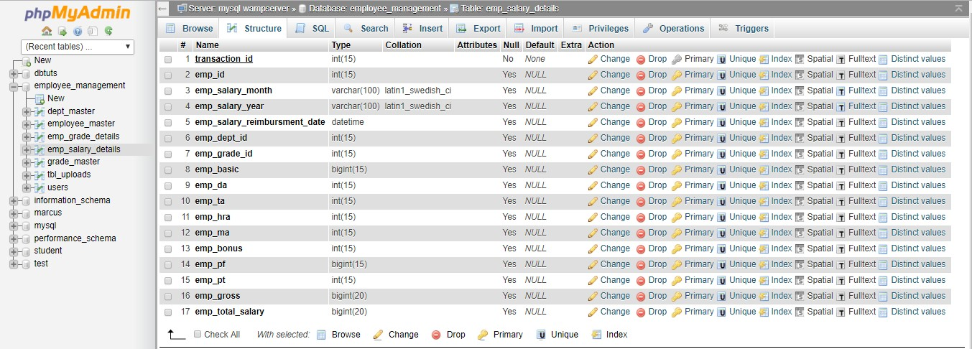

### SAMPLE CODES

#### Index.php

<?php session_start();

?>

<!DOCTYPE html>

<html>

<head>

<meta name="viewport" content="width=device-width, initial-scale=1">

<style>

body {font-family: Arial, Helvetica, sans-serif;}

/* Full-width input fields */ input[type=text], input[type=password] {

width: 100%; padding: 12px 20px; margin: 8px 0; display: inline-block;

border: 1px solid #ccc; box-sizing: border-box;

}

/* Set a style for all buttons */ button {

background-color: #4CAF50; color: white;

padding: 14px 20px; margin: 8px 0; border: none; cursor: pointer;

width: 100%;

}

button:hover { opacity: 0.8;

}

/* Extra styles for the cancel button */

.cancelbtn { width: auto;

padding: 10px 18px; background-color: #f44336;

}

/* Center the image and position the close button */

.imgcontainer {

text-align: center; margin: 24px 0 12px 0; position: relative;

}

img.avatar { width: 40%;

border-radius: 50%;

}

.container { padding: 16px;

}

span.psw { float: right;

padding-top: 16px;

}

/* The Modal (background) */

.modal {

display: none; /* Hidden by default */ position: fixed; /* Stay in place */

z-index: 1; /* Sit on top */ left: 0;

top: 0;

width: 100%; /* Full width */ height: 100%; /* Full height */

overflow: auto; /* Enable scroll if needed */ background-color: rgb(0,0,0); /* Fallback color */

background-color: rgba(0,0,0,0.4); /* Black w/ opacity */ padding-top: 60px;

}

/* Modal Content/Box */

.modal-content { background-color: #fefefe;

margin: 2% auto 10% auto; /* 5% from the top, 15% from the bottom and centered */ border: 1px solid #888;

width: 40%; /* Could be more or less, depending on screen size */

}

/* The Close Button (x) */

.close {

position: absolute; right: 25px;

top: 0;

color: #000;

font-size: 35px; font-weight: bold;

}

.close:hover,

.close:focus { color: red; cursor: pointer;

}

/* Add Zoom Animation */

.animate {

-webkit-animation: animatezoom 0.6s; animation: animatezoom 0.6s

}

@-webkit-keyframes animatezoom { from {-webkit-transform: scale(0)} to {-webkit-transform: scale(1)}

}

@keyframes animatezoom { from {transform: scale(0)} to {transform: scale(1)}

}

/* Change styles for span and cancel button on extra small screens */ @media screen and (max-width: 300px) {

span.psw { display: block; float: none;

}

.cancelbtn { width: 100%;

}

}

.button {

background-color: #000000; color: #FFFFFF;

padding: 10px; border-radius: 10px;

-moz-border-radius: 10px;

-webkit-border-radius: 10px; margin:10px

}

.small-btn { width: 50px; height: 25px;

}

.medium-btn { width: 70px; height: 30px;

}

.big-btn { width: 180px; height: 40px;

}

</style>

<?php include("header12.php");

include("dbconnect.php"); extract($_POST);

if(isset($submit))

{

$rs=mysql_query("select * from users where username='$username' and password= MD5('$password')"); if(mysql_num_rows($rs)<1)

{

$found="N";

}

else

{

$_SESSION[login]=$username; header("Location: welcome.php");

}

}

?>

</head>

<body>

<center>

</br></br></br>

<h1><strong>MY EMPLOYEE MANAGER</strong></h1>

<br>

<h1><STRONG>ADMINISTRATOR &nbsp; LOGIN</STRONG></h1>

<button onclick="document.getElementById('id01').style.display='block'" class="button big-btn" style="width:10%; font-size : 20px;"><strong>Login</strong></button>

</center>

<div id="id01" class="modal">

<form class="modal-content animate" name="form1" method="post" action="">

<div class="imgcontainer">

<span onclick="document.getElementById('id01').style.display='none'" class="close" title="Close Modal">&times;</span>

<img src="admin.png" alt="Avatar" class="avatar">

</div>

<div class="container">

<label for="uname"><b>Username</b></label>

<input type="text" placeholder="Enter Username" name="username" id="username" required>

<label for="psw"><b>Password</b></label>

<input type="password" placeholder="Enter Password" name="password" id="password" required>

<button type="submit" name="submit" id="submit" value="Login">Login</button>

<!-- <label>

<input type="checkbox" checked="checked" name="remember"> Remember me

</label>-->

</div>

<div class="container" style="background-color:#f1f1f1">

<button type="button" onclick="document.getElementById('id01').style.display='none'" class="cancelbtn">Cancel</button>

<!-- &nbsp;&nbsp;&nbsp;&nbsp;&nbsp;&nbsp;&nbsp;&nbsp;&nbsp;&nbsp;&nbsp;&nbsp; <button onclick="document.getElementById('id02').style.display='block'" class="button big-btn" style="width:50%; font-size : 20px;"><strong>Forget Password</strong></button> -->

</div>

</form>

</div>

<div id="id02" class="modal">

<form class="modal-content animate" method="post" action="">

<div class="imgcontainer">

<span onclick="document.getElementById('id02').style.display='none'" class="close" title="Close Modal">&times;</span>

</div>

<div class="container">

<label for="uname"><b>Enter Your Email id</b></label>

<input type="text" placeholder="Enter Username" name="username" id="username" required>

<input type="submit" name="submi" value="Submit">

</div>

</form>

</div>

<script>

// Get the modal

var modal = document.getElementById('id01'); var modal = document.getElementById('id02');

// When the user clicks anywhere outside of the modal, close it window.onclick = function(event) {

if (event.target == modal) { modal.style.display = "none";

}

}

</script>

#### Welcome.php

<?php session_start();

include "header.php";

?>

<!doctype html>

<html>

<head>

<style>

.button {

background-color: #000000; color: #FFFFFF;

padding: 10px; border-radius: 10px;

-moz-border-radius: 10px;

-webkit-border-radius: 10px; margin:10px

}

.small-btn { width: 50px; height: 25px;

}

.medium-btn { width: 70px; height: 30px;

}

.big-btn {

width: 250px; height: 40px;

}

</style>

<meta charset="utf-8">

<title>Untitled Document</title>

</head>

<body class="bg">

<center>

<br>

<form action="emp_master.php" align= "center">

<!--<div class="button big-btn">This is a big button</div>-->

<button type="submit" class="button big-btn" value="emp_master" name="add" ><font size="3"><strong>Add New Employee</strong></font></button>

</form>

<br>

<form action="dep_master.php">

<button type="submit" class="button big-btn" value="" name="add" ><font size="3"><strong>Add New Department</strong></font></button>

</form>

<br>

<form action="grad_master.php">

<button type="submit" class="button big-btn" value="#" name="add" ><font size="3"><strong>Add New Grade</strong></font></button>

</form>

<br>

<form action="emp_grad_detail.php">

<button type="submit" class="button big-btn" value="#" name="add" ><font size="3"><strong>Employee Grade Details</strong></font></button>

</form>

<br>

<form action="salary_detail.php">

<button type="submit" class="button big-btn" value="#" name="add" ><font size="3"><strong>Prepare Monthly Salary</strong></font></button>

</form>

<br>

<form action="report.php">

<button type="submit" class="button big-btn" value="#" name="add" ><font size="3"><strong>Generate Report</strong></font></button>

</form>

</table>

</form>

</center>

</body>

</html>

#### emp_master.php

<?php session_start();

include_once "header.php";

?>

<?php

include_once 'dbconnnect.php'; if(isset($_POST['submit']))

{

$file = rand(1000,100000)."-".$_FILES['file']['name'];

$file_loc = $_FILES['file']['tmp_name'];

$file_size = $_FILES['file']['size'];

//echo $file_size;

$file_type = $_FILES['file']['type'];

$folder="uploads/";

// new file size in KB

$new_size = $file_size/1024; echo $new_size;

// new file size in KB

// make file name in lower case

$new_file_name = strtolower($file);

// make file name in lower case

$final_file=str_replace(' ','-',$new_file_name);

if(move_uploaded_file($file_loc,$folder.$final_file))

{

$sql="INSERT INTO tbl_uploads(file,type,size) VALUES('$final_file','$file_type','$new_size')";

$_SESSION['final_file']=$final_file; mysqli_query($connection,$sql);

?>

<script>

alert('successfully uploaded'); window.location.href='emp_master.php?success';

</script>

<?php

}

else

{

?>

# Features of Employee database and payroll management system:

* Easy to use.
* It is completely secure.
* It is completely controlled by admin.
* This system is easily compatible with most of the web browsers.
* It is very interactive and saves time.
* Reduces paper works.
* Calculations are automated so it is highly accurate.
* Admin can view all the records whenever necessary with ease.

**Future scope of the work:**

* The option to print the records In future.
* I intend to add a leave structure in the future.
* I would like to implement a regular backup mechanism to back up the employee database to avoid disasters.
* The system can be developed in such a way that its existing features can be modified to better versions.

## Conclusion:

This project is built keeping in mind that it is to be used by only one user that is the admin. It is built for use in small scale organization where the number of employees is limited. According to the requested requirement the admin can add, manipulate, update and delete all employee data in his organization. The admin can add new departments and delete them. The Admin can also add predefined pay grades for the employees. The required records can be easily viewed by the admin anytime time he wants in an instant. The payment of the employee is based on monthly basis. Numerous validations implemented would enable the admin to enter accurate data. The main objective of this framework is to save time, make the system cost effective and management records efficiently.

## Bibliography:

Websites:

* [www.w3schools.com](http://www.w3schools.com/)
* [www.tutorialspoint.com](http://www.tutorialspoint.com/)
* [www.youtube.com](http://www.youtube.com/)